In vivo effectiveness of a starch absorption blocker in a double-blind placebo-controlled study with normal subjects

Joe A. Vinson, PhD, Donna M. Shuta, BS and Hassan Al Kharrat, MS
Department of Chemistry
University of Scranton
Scranton, PA 18510
Analysis data were obtained from the first study done reported on September 6, 2001and the second study on November, 20, 2001. The total subjects from both studies numbered 20. Nine were excluded who did not furnish all blood samples or who had a negative area for the plasma glucose-time curve and were therefore poor absorbers.
Of the 11 subjects, 8 were female and 3 were male, ranging in age from 21 to 57. The Bio-Phase 2250™ group had significantly lower plasma glucose at 60 minutes and almost significantly lower glucose at 45 minutes. The area of the
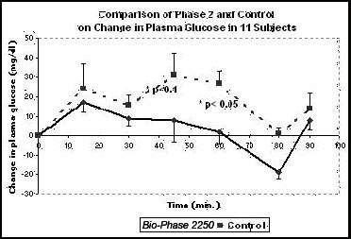

curve (area above the baseline which is 0 to 62 minutes for Bio-Phase 2250™ and 0 to 80 minutes for the control), which represents glucose absorption and metabolism, was 66% smaller with Bio-Phase 2250™ .
This product shows effectiveness in both sedentary college-age subjects and physically active adults.

